**Project Report**

**On**

**Intelligent Customer Help Desk with Smart Document Understanding**

**Category: Artificial Intelligence and Machine Learning**

**By**

**Atharva R. Kale**

**(**[**atharvakale31@gmail.com**](mailto:atharvakale31@gmail.com)**)**

**Intelligent Customer Help Desk with Smart Document Understanding**

**Problem:**

The typical customer care chatbot can answer simple questions, such as store locations and hours, directions, and maybe even making appointments. When a question falls outside of the scope of the pre-determined question set, the option is typically to tell the customer the question isn’t valid or offer to speak to a real person.

**Project Description:**

In this project, there is another option. If the customer question is about the operation of a device, the application passes the question onto Watson Discovery Service, which has been pre-loaded with the device’s owners manual. So now, instead of “Would you like to speak to a customer representative?” we return relevant sections of the owners manual to help solve our customers’ problems.

Taking it a step further, the project makes use of the Smart Document Understanding feature of Watson Discovery to train it on what text in the owners manual is important and what is not. This improve thes answers returned from the queries.

**Requirements:**

#### **Project Requirements**: IBM Cloud, IBM Watson, Node-RED

#### **Functional Requirements:** IBM Cloud

#### **Technical Requirements**: Watson AI, Node JS, AI, ML.

#### **Software Requirements**: Watson Assistant, Watson Discovery, Watson Cloud Functions, Node-RED

**Project Deliverables:** Intelligent Customer Help Desk with Smart Document Understanding

#### **Project Team:** Atharva R. Kale

#### **Project Duration:** 30 Days

**Scope of Work:**

* Required services need to be setup on IBM cloud starting with Watson Assistant.
* Create a dialog skill for customer care chat box.
* Upload the required document to Watson discovery and configure it.
* Create cloud function Action to allow Watson assistant to post queries to Watson discovery.
* Join these two services using webhooks.
* Create and deploy a Node-RED application to create a Web UI for a chat box which integrates Watson assistant.

**Block / Flow Diagram:**

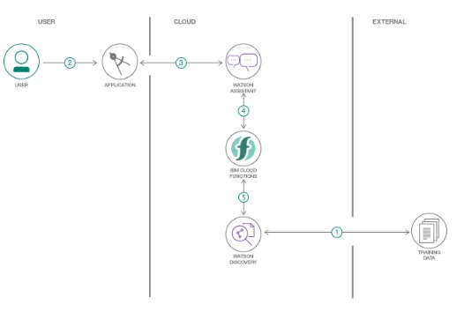

**ChatBot in work:**

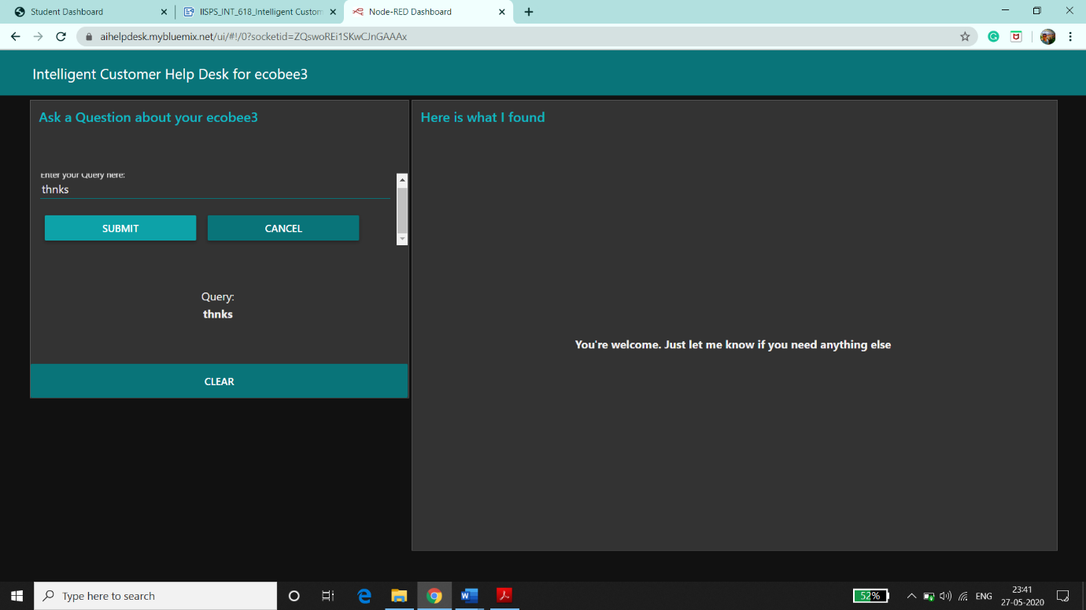

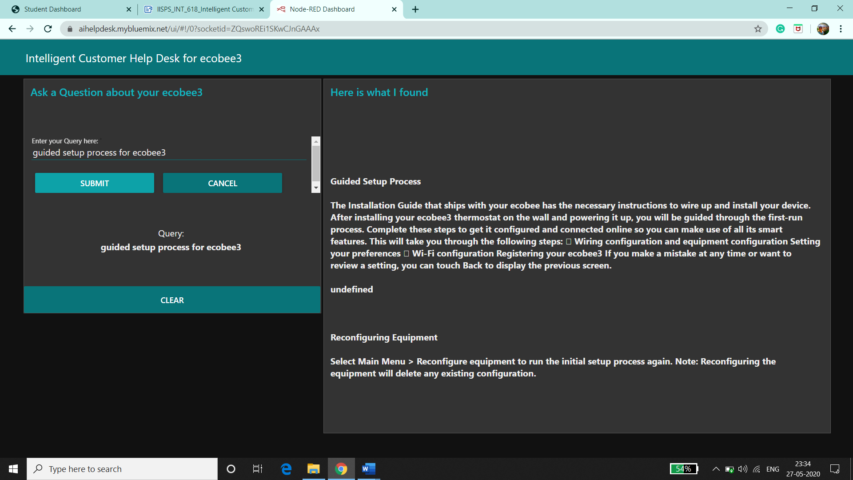

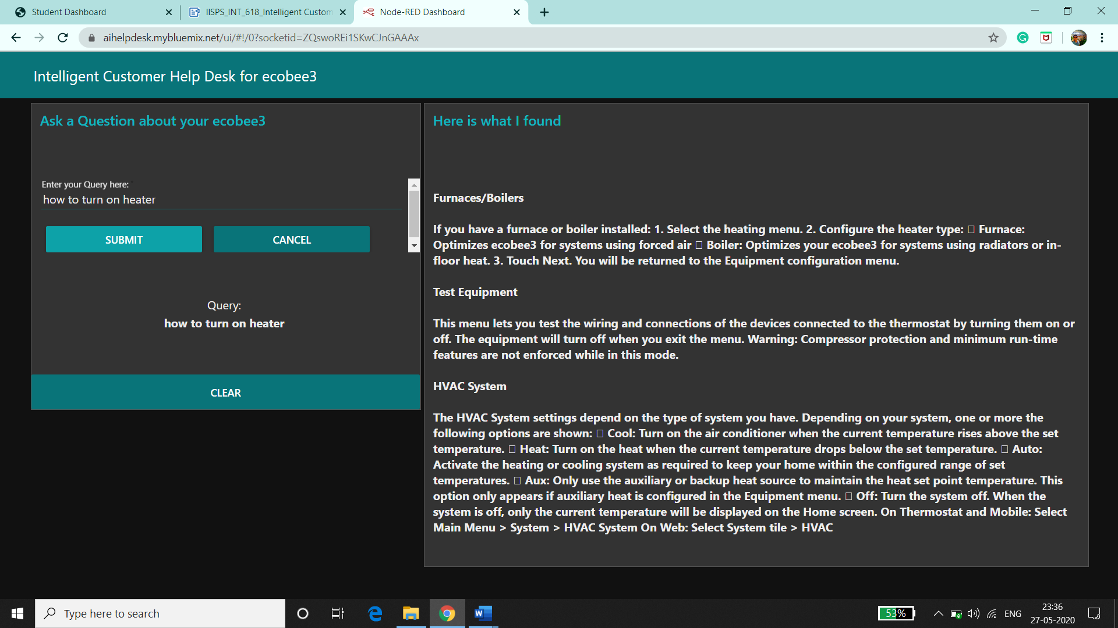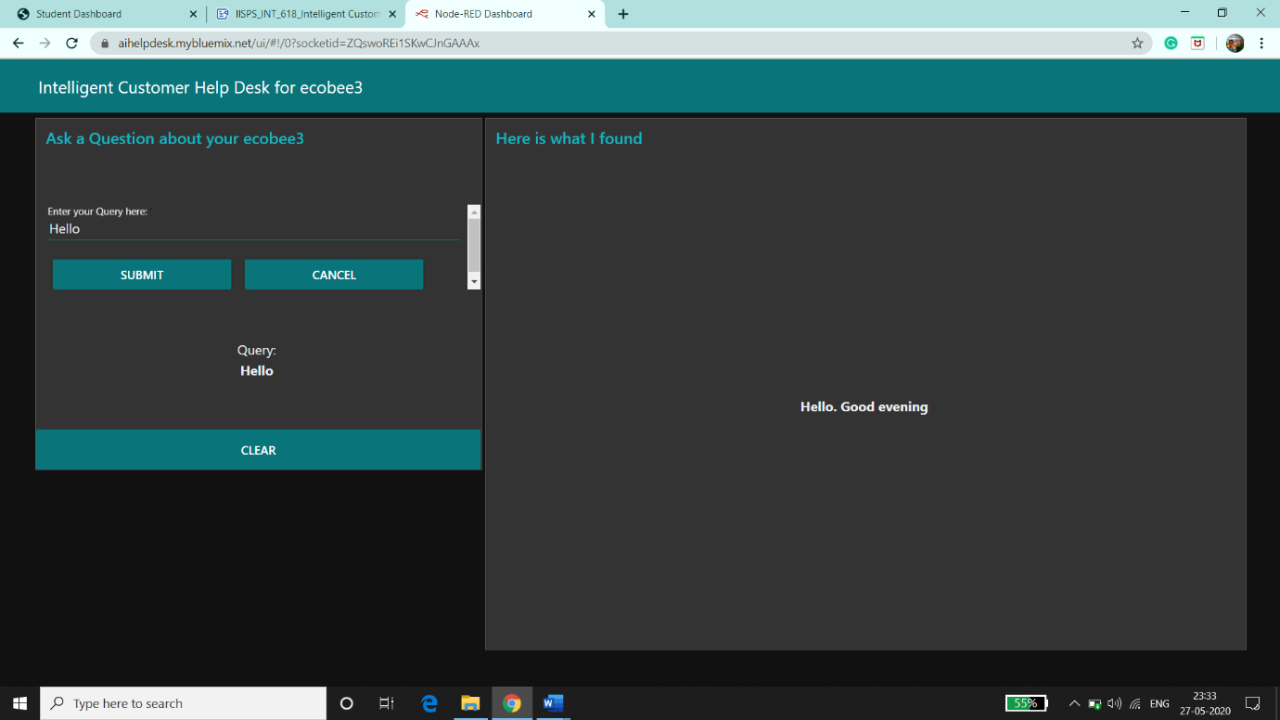

**Applications:**

1. This chatbot can be deployed by companies to solve basic queries.
2. It can be used to deploy as Customer Helpdesk for small scale products as their manual usually has the solution for the user's problems.

**Conclusion:**

An Intelligent Customer Helpdesk Chatbot was created using various Watson services like Watson Discovery, Watson Assistant, Watson Cloud Functions and Node-RED.

Link: <https://aihelpdesk.mybluemix.net/ui>

**Future Scope:**

In the future, various other Watson services like Text-To-Speech and Speech-To-Text can be integrated in the chatbot. This can make the chatbot Hands-free.